Low-Code Experiment
Data Modelling and Form Design for a Business Application in Zoho Creator
SHRIVISHAL .SV
241501202
AIML
Abstract
This experiment designs the data model and form for a Hotel Room Booking application in Zoho Creator. A form named Room Booking Form was built using the thirteen basic field types, grouped into four sections, and a report was created to list the submitted booking requests. Field validations were applied and the form was tested by submitting sample bookings.
1. Aim
To design a Room Booking Form in Zoho Creator using the basic field types, apply field validations, and view the submitted booking requests in a report.
2. Introduction
A hotel that takes bookings through phone calls and messages has no structured record of its guests until they arrive. A single online form solves this by collecting the guest details, room preferences and arrival schedule in a fixed format. In Zoho Creator, each field on a form becomes a column of the data table, so designing the form is the same as designing the data model of the application.
The form in this experiment uses the thirteen basic fields: Name, Email, Address, Phone, Single Line, Multi Line, Number, Date, Time, Drop Down, Radio, Multi Select and Checkbox.
3. Form Design
The fields are organized into four sections so that the form is easy for a guest to follow.
Section | Field Name | Field Type | Purpose
A. Guest Details | Guest Name | Name | Full name of the guest (first and last name)
 | ID Proof Number | Single Line | Identification document number
 | Number Of Guests | Number | Total number of guests
B. Contact Details | Email Address | Email | Email for the booking confirmation
 | Contact Number | Phone | Mobile number with country code
 | Permanent Address | Address | Residential address for records
C. Room and Stay Preferences | Room Type | Drop Down | Choose one room category

1
Section | Field Name | Field Type | Purpose
 | Meal Plan | Radio | Room Only, Breakfast Included or All Meals Included
 | Amenities Required | Multi Select | One or more extra amenities
 | Special Requests | Multi Line | Free-text remarks
D. Scheduling and Policy | Check In Date | Date | Intended check-in date
 | Preferred Checkin  Time | Time | Expected arrival time
 | Agree To Hotel  Policies | Checkbox | Acknowledgement of hotel policies

4. Procedure
Step 1: Create the form and add fields. Inside the HOTEL BOOKING application, a new form named Room Booking Form was created. The fields were dragged from the Basic Fields palette onto the form, and sections were used to group them. Figure 1 shows the Guest Details and Contact Details sections, and Figure 2 shows the Room and Stay Preferences and Scheduling and Policy sections.
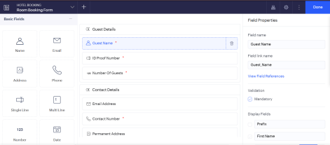

Figure 1: Form Builder: Guest Details and Contact Details sections
2
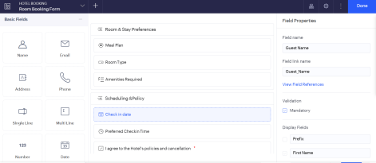

Figure 2: Form Builder: Room and Stay Preferences and Scheduling and Policy sections
Step 2: Set field properties and validations. For each field, the field name and link name were checked in the Field Properties panel, and the Mandatory option was ticked for the required fields. Required fields are marked with a red asterisk on the form. Figure 3 shows the properties of the Number Of Guests field.
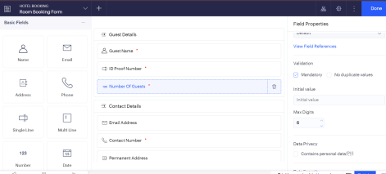

Figure 3: Field Properties of the Number Of Guests field
Step 3: Preview the form. The form was opened using Access Development Live. The Contact Number field shows the India (+91) country code format (Figure 4).
3
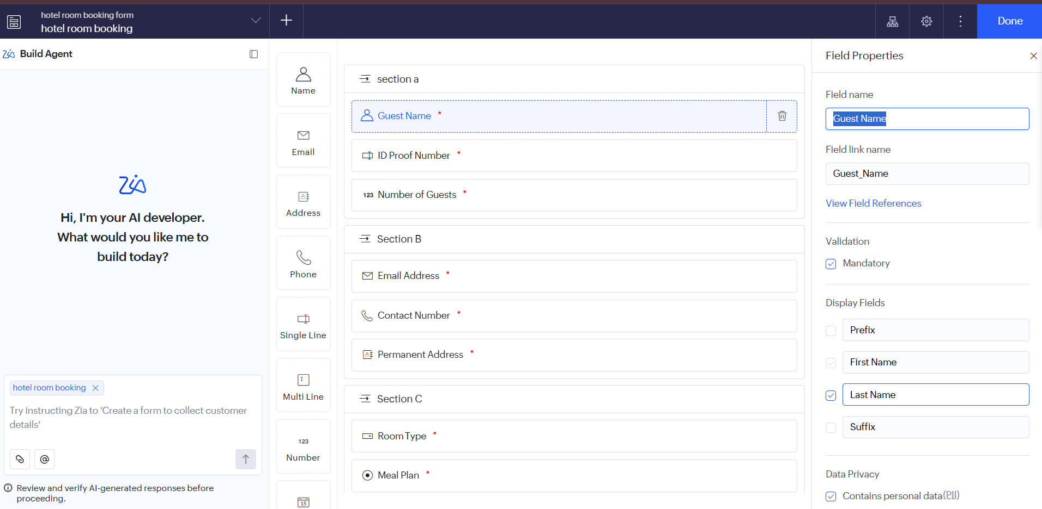

Figure 4: Live form opened in the browser
Step 4: Test the validation. The form was submitted with required fields left empty. Zoho Creator blocked the submission, showed the message Invalid entries found, and marked the empty fields with the message This field is mandatory. Enter a value. (Figure 5).

Figure 5: Mandatory field validation message on submit
Step 5: Submit sample bookings and view the report. Three sample booking requests were submitted. The report named Room Booking Report lists each submission as a row, with one column for each form field (Figures 6 and 7).
4
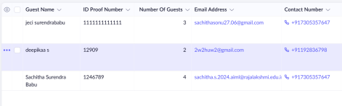

Figure 6: Room Booking Report: guest and contact columns
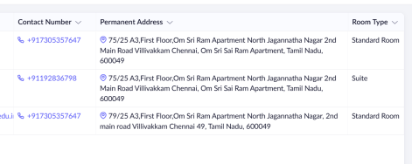

Figure 7: Room Booking Report: address and room type columns
5. Validations Applied
Field | Validation
Guest Name, ID Proof Number, Number Of Guests, Contact Number | Mandatory
Agree To Hotel Policies | Mandatory, so the form cannot be submitted unless it is ticked
Email Address | Built-in email format check of the Email field type
Contact Number | Phone field with the India (+91) country code

6. Result
The Room Booking Form was built with the basic field types, tested with sample data, and the submitted bookings appear in the Room Booking Report.
7. Conclusion
A form in Zoho Creator is both the data entry screen and the data model of the application. Choosing the right field type for each piece of information gives built-in validation and a clean report with no extra coding.
5
8. Learning Outcome
This experiment gives practice in choosing field types, grouping fields into sections, applying mandatory validations, and viewing form data in a report.
6

